Database Engineer Capstone

## Capstone Project Task

Set up the Little Lemon database

Create and implement an ER diagram

Commit the project in Git

Create sales reports

Build a booking system

Generate data insights

Create a database client

1. Entity relationship model: Used to build the Little Lemon relational database system
2. MySQL Workbench: Visual tool for database modeling and data management
3. Git: A version control system to which you can commit your project
4. GitHub: Includes the source control management features of Git along with other features
5. Virtual tables: An interface that provides access to data stored in tables in the database
6. JOINS: Link records of data between one or more tables based on a common column
7. Stored procedures: Reusable code that can be invoked and executed efficiently
8. Prepared statement: MySQL compiles and parses just once, and then knows it’s safe to execute
9. Triggers: Stored a set of actions in the form of a stored program that can be invoked automatically
10. Working with Tableau:

Connect your data sources, Prepare your data for analysis, Create a visualization of your data, Produce interactive dashboards

1. Create a database client:

Identify which version of Python is running on your machine, Install the Jupyter IDE to run your code on, Connect Python to the Little Lemon MySQL database, Begin working with your database client

## Introduction

The Professional Certificates create opportunities so that anyone, regardless of education, background or experience, can learn high-quality skills to land a high-growth career. There is no degree or experience required to get started.

In this course, you’ll complete a capstone project in which you’ll create a database and client for Little Lemon restaurant. To complete this course, you will need database engineering experience from the previous courses.

The Capstone project enables you to demonstrate multiple skills from the Certificate by solving an authentic real-world problem. Each module includes a brief recap of, and links to, content that you have covered in previous courses in this program.

In this course, you will demonstrate your new skillset by designing and composing a database solution, combining all the skills and technologies you've learned throughout this program to solve the problem at hand.

By the end of this course, you’ll have proven your ability to:

**•** Set up a database project,

**•** Add sales reports,

**•** Create a table booking system,

**•** Work with data analytics and visualization,

**•** And create a database client.

You’ll also demonstrate your ability with the following tools and software:

**•** Git,

**•** MySQL Workbench,

**•** Tableau,

**•** And Python.

**Module one**

In the first module, you’ll receive an introduction to the Little Lemon project environment and help them to set up their database.

You’ll then recap processes and concepts related to setting up the project environment. Once you have completed each recap, you’ll then carry out a related task.

By the end of this module, you’ll be able to:

**•** Set up a repository,

**•** Set up a MySQL instance server in MySQL Workbench,

**•** Create and implement an ER diagram data model,

**•** And commit the project.

**Module two**

During the second module, you’ll continue to help Little Lemon manage their database by adding sales reports and creating a table booking system. Like module one, you’ll recap key processes and concepts to help you complete the module tasks.

In the first lesson, you’ll create a virtual table using JOINs to summarize the restaurant’s data. You’ll also create optimized queries to manage and analyze data. You’ll then commit your progress to Git.

In the second lesson, you’ll create SQL queries to check available bookings based on user input. You’ll also create SQL queries to add and update bookings. You’ll then test your queries and commit your progress to Git.

By the end of this module, you’ll have demonstrated your ability to:

**•** Create a virtual table,

**•** Create optimized queries,

**•** Test SQL queries,

**•** And commit your progress to Git.

**Module three**

The third module requires you to help Little Lemon using data visualization and database clients. Again, during this module you’ll review key processes and concepts to assist you with these tasks.

In the first lesson, you’ll set up a Tableau Workspace in which you’ll create an interactive dashboard to present Little Lemon’s sales and profits.

In the second lesson, you’ll create a database client using Python. You’ll then implement functions to query the database. Finally, you’ll commit your progress to Git.

By the end of this module, you’ll have shown that you can:

**•** Work with Tableau to create interactive dashboards,

**•** Create a database client,

**•** And add query functions.

**Module four**

In the final module, you’ll review your Little Lemon database. You’ll then present your Little Lemon database to another learner for review. Likewise, you’ll also receive another learner’s Little Lemon database for review. Finally, you’ll then review an exemplar of the Little Lemon database to compare your own against.

## Data

LittleLemon_data.xlsx

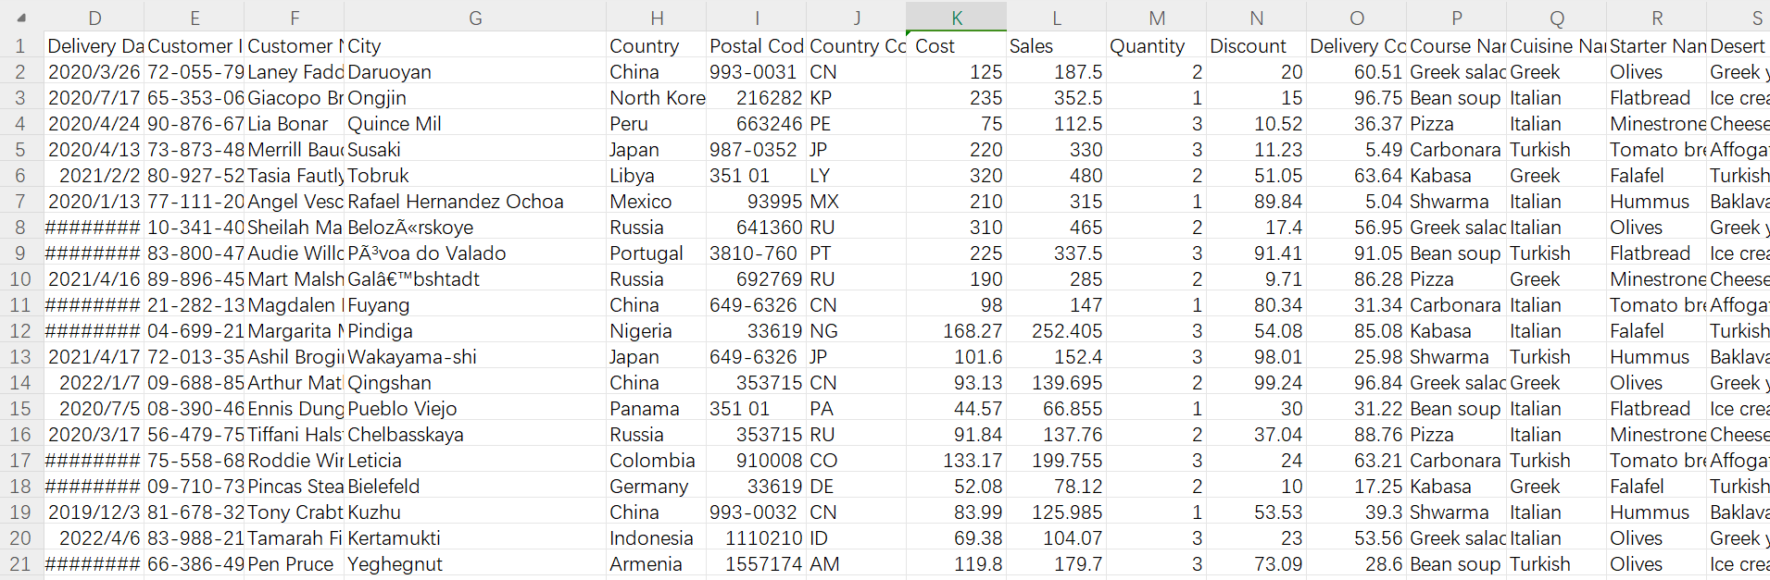

Colmns:

• Delivery Date

• Customer ID

• Customer Name

• City

• Country

• Post Code

• Country Code

• Cost

• Sales

• Quantity

• Discount

• Delivery Cost

• Course Name

• Cuisine Name

• Starter Name

• Desert Name

• Drink

• Sides

## Exercise1: Create an ER diagram data model and implement it in MySQL

**Scenario**

Little Lemon needs to build a robust relational database system in MySQL in which they can store large amounts of data. They then need to easily manage and find this data as required. This database system should maintain information about the following aspects of the business:

• Bookings.

• Orders.

• Order delivery status.

• Menu.

• Customer details.

• and Staff information.

### Task 1.1

In this task, you need to create a normalized ER diagram (that adheres to 1NF, 2NF and 3NF) with relevant relationships to meet the data requirements of Little Lemon. When creating your diagram, include the following tables:

• Bookings: To store information about booked tables in the restaurant including booking id, date and table number.

• Orders: To store information about each order such as order date, quantity and total cost.

• Order delivery status: To store information about the delivery status of each order such as delivery date and status.

• Menu: To store information about cuisines, starters, courses, drinks and desserts.

• Customer details: To store information about the customer names and contact details.

• Staff information: Including role and salary.

Here is some guidance for completing this task:

• Identify entities and related attributes.

• Identify primary and foreign keys.

• Define data types and constraints.

Once you have designed your ER diagram inside your MySQL Workbench Model Editor you then need to save your data model as LittleLemonDM and export it as a PNG file.

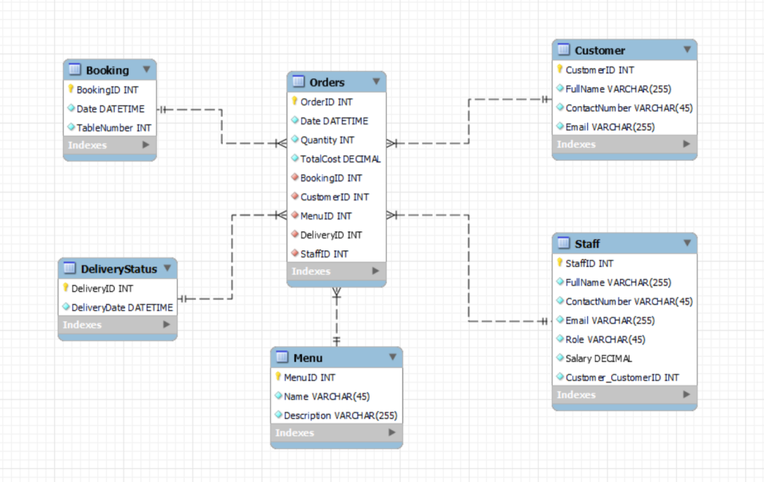

### Task 1.2

In this second task, you need to implement the Little Lemon data model inside your MySQL server. Here is some guidance for completing this task:

• Use the forward engineer method in MySQL Workbench to implement the Little Lemon data model inside MySQL server.

• Name your database LittleLemonDB.

• Export the LittleLemonDB as a single contained SQL file and save it in the db-capstone-project folder.

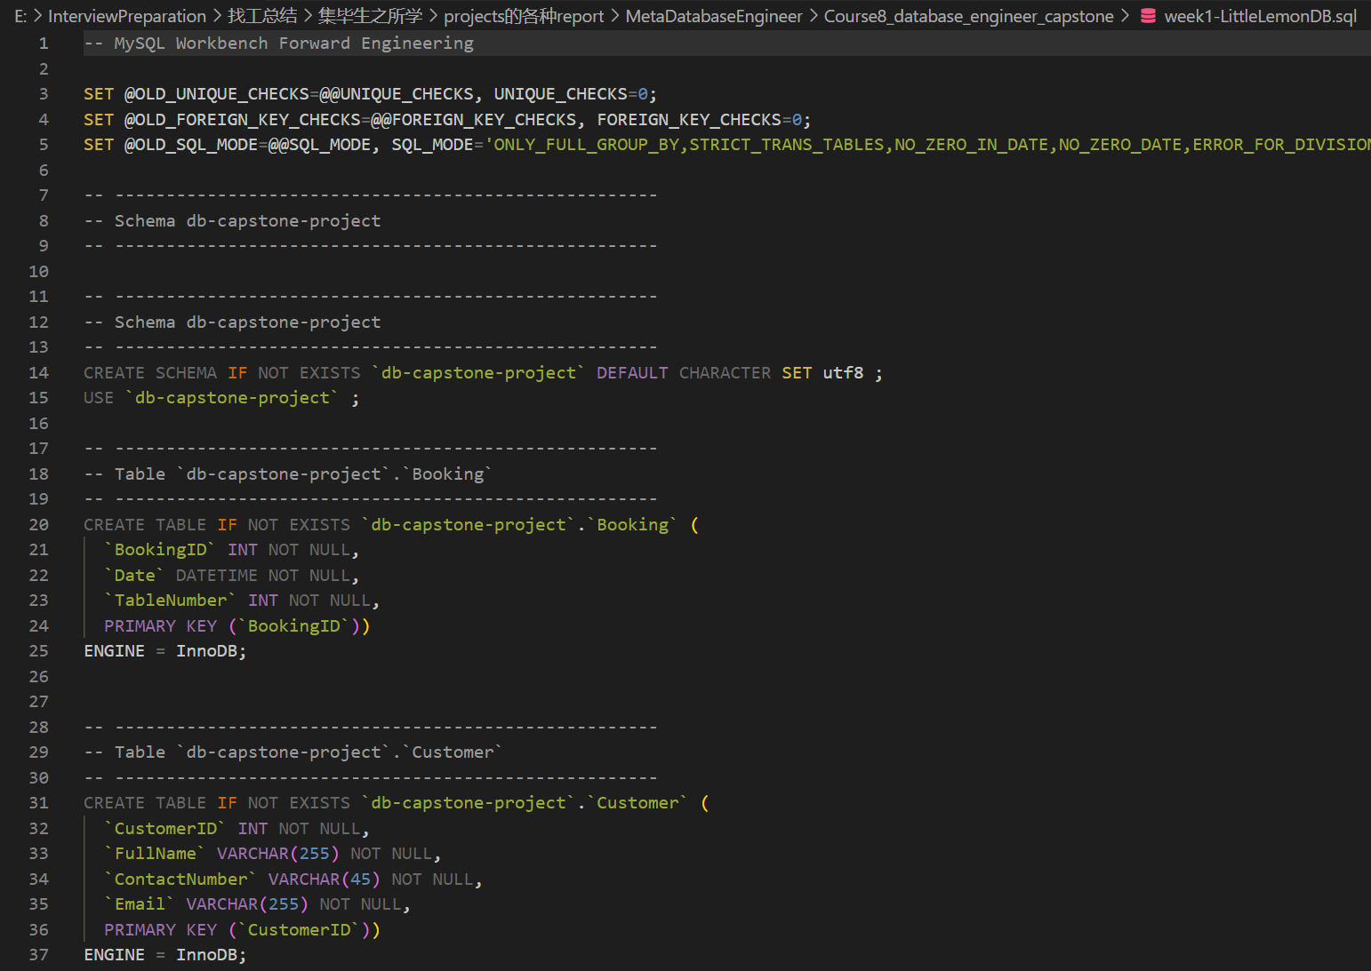

### Task 1.3

In the third and final task, you need to show the databases in the MySQL server. Write a SQL code inside MySQL Workbench SQL editor to show all your databases in MySQL server. Check if the Little Lemon database is included in the list.

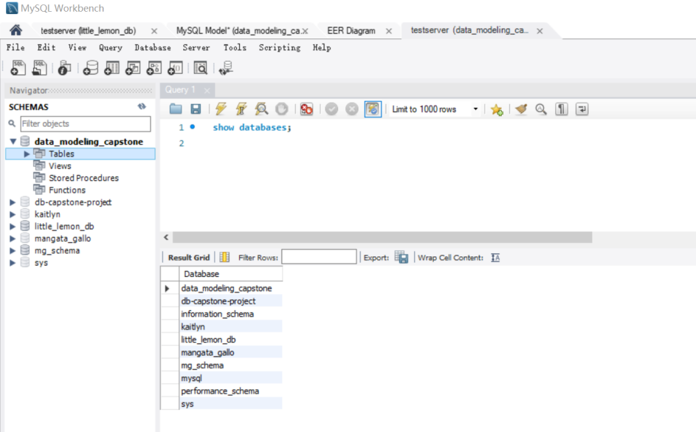

## Exercise2: Create a virtual table to summarize data

**Scenario**

Little Lemon needs to retrieve data from their database. You can use your knowledge of MySQL to help them. As part of this task, you need to:

• Create a virtual table to summarize data.

• Use a JOIN statement to query data from multiple tables.

• Create a SQL statement with a subquery.

You can carry out these steps using your knowledge of virtual tables, JOIN statements and SQL queries. Review the instructions that follow for guidance on completing these tasks.

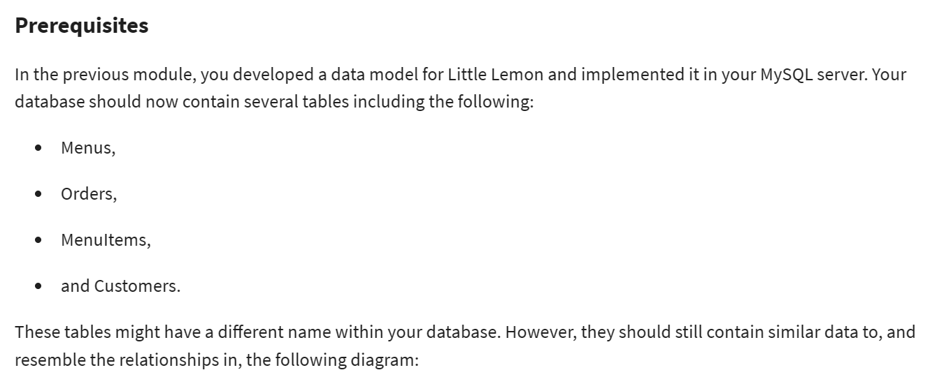

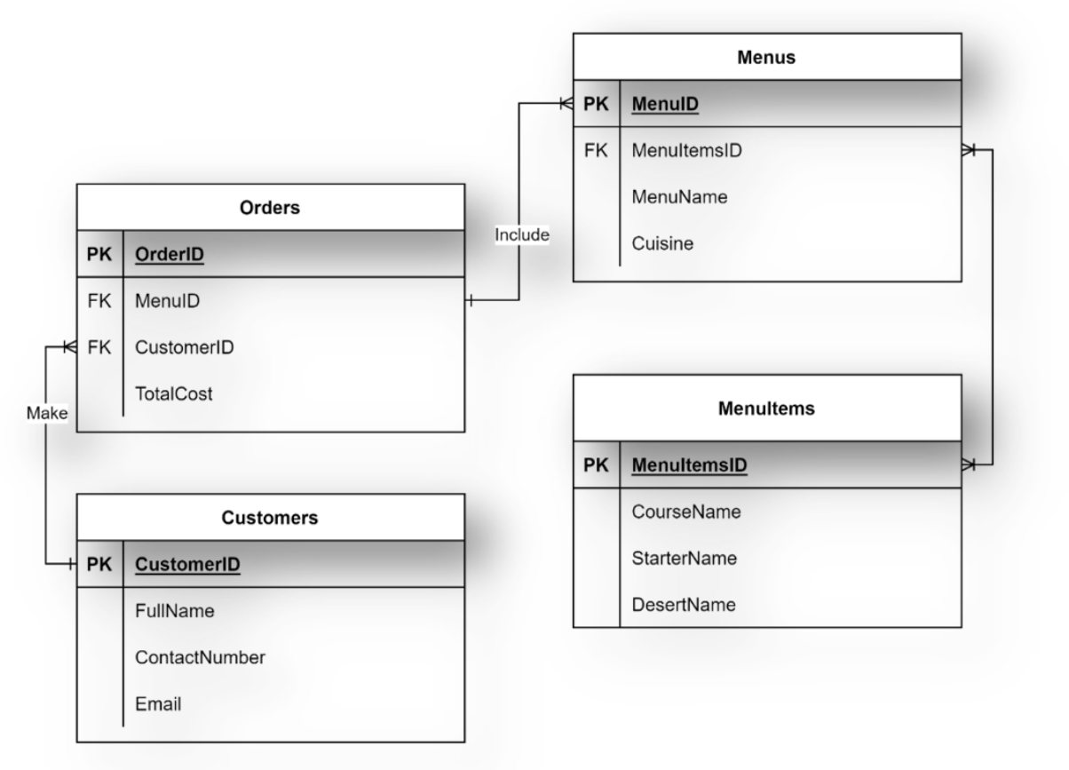

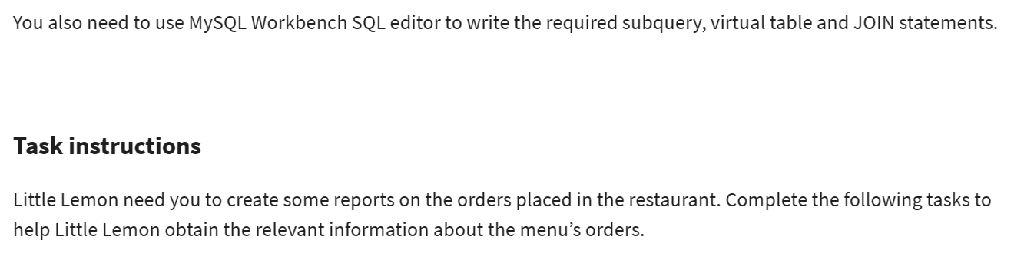

### Task 2.1

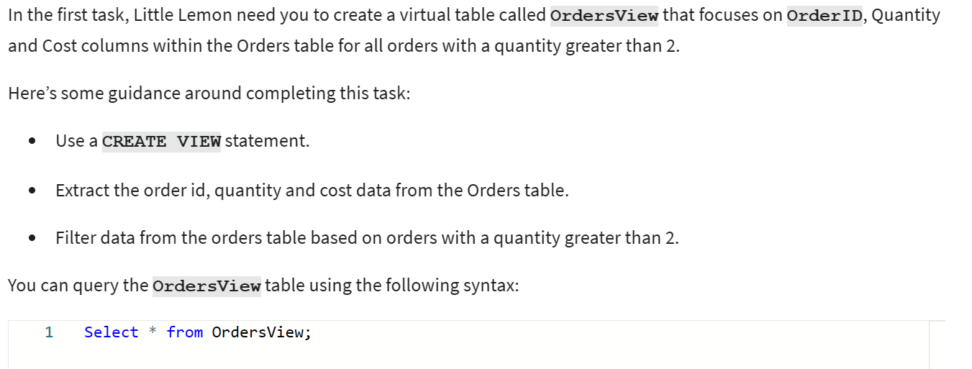

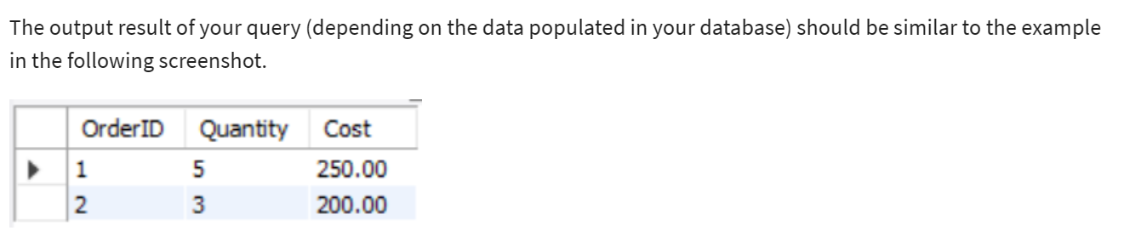

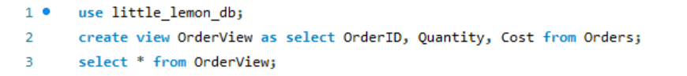

### Task 2.2

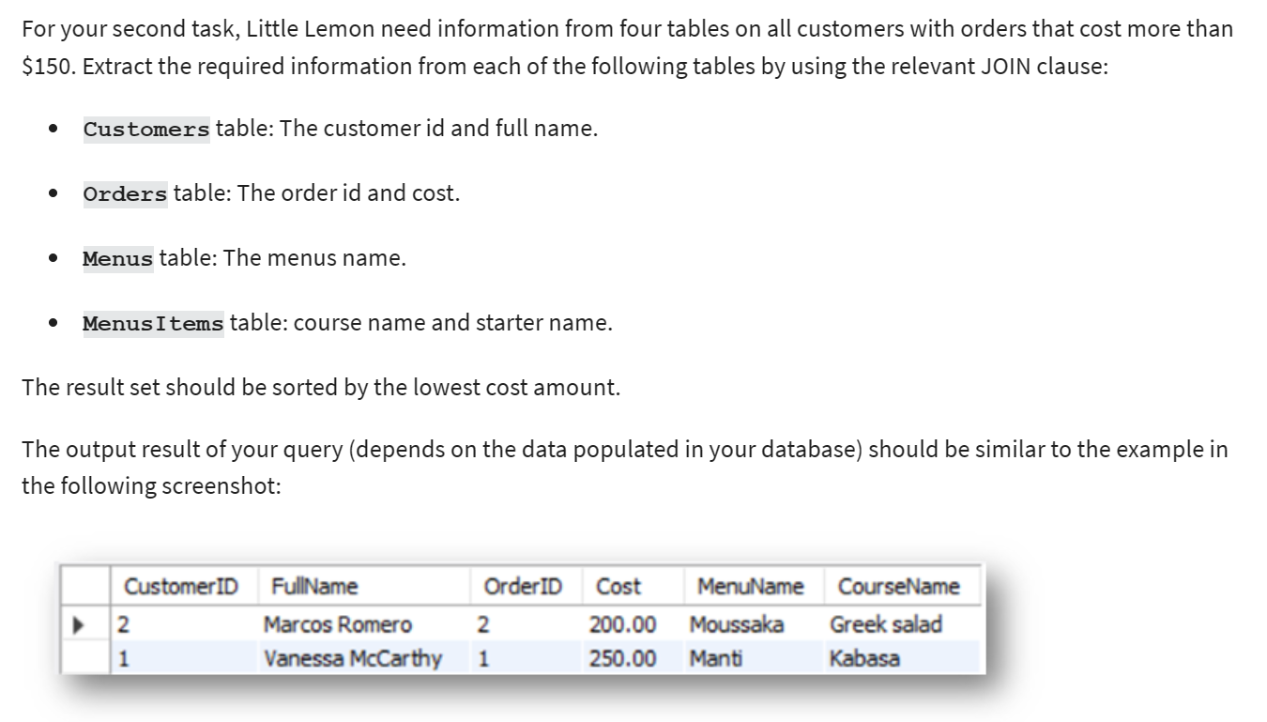

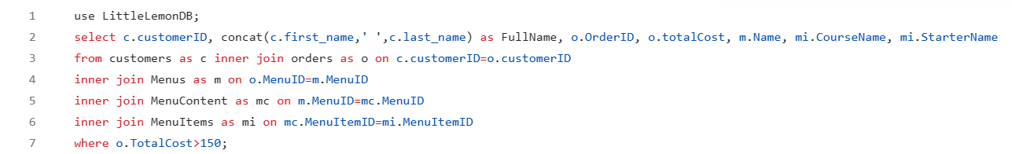

### Task 2.3

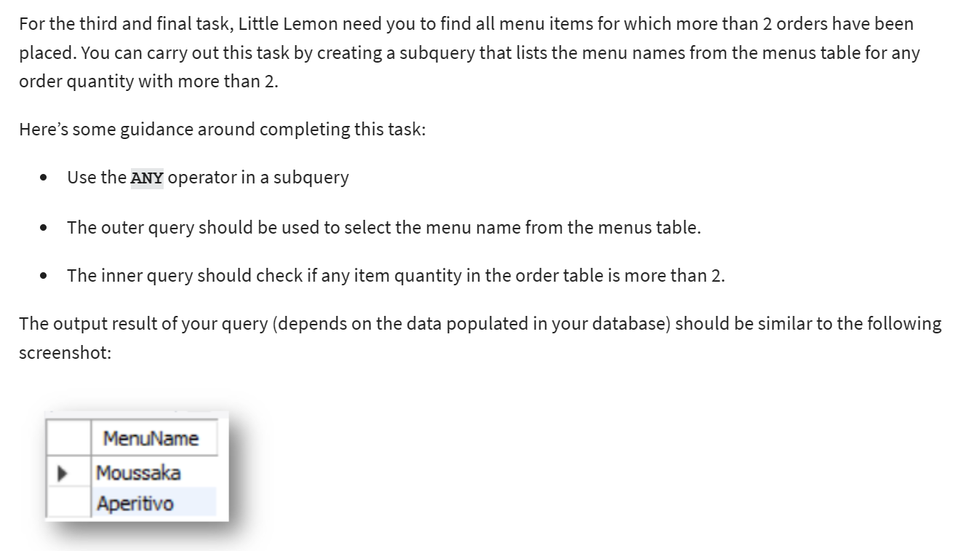



## Exercise 3: Create optimized queries to manage and analyze data

**Scenario**

Little Lemon need to query the data in their database. To do this, they need your help with creating optimized queries using stored procedures and prepared statements.

**Prerequisites**

In the previous module, you developed a data model for Little Lemon and implemented it in your MySQL server. Your database should now contain several tables including the following:

• Menus,

• Orders,

• MenuItems,

• and Customers.

These tables might have different names within your database. However, they should still contain similar data to, and resemble the relationships in, the following diagram:



You also need to use MySQL Workbench SQL editor to write the required stored procedures and prepared statements.

### Task 3.1

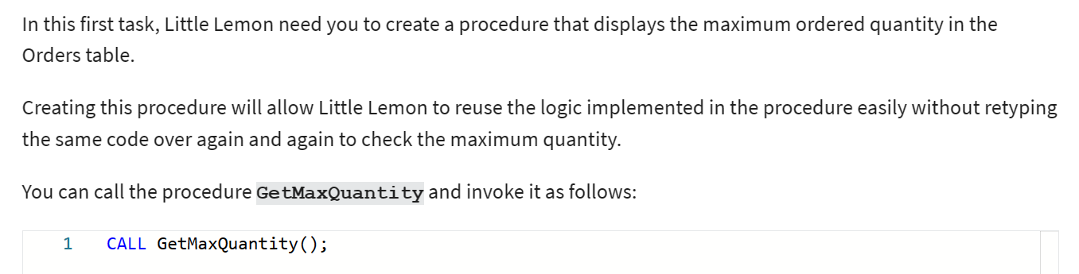

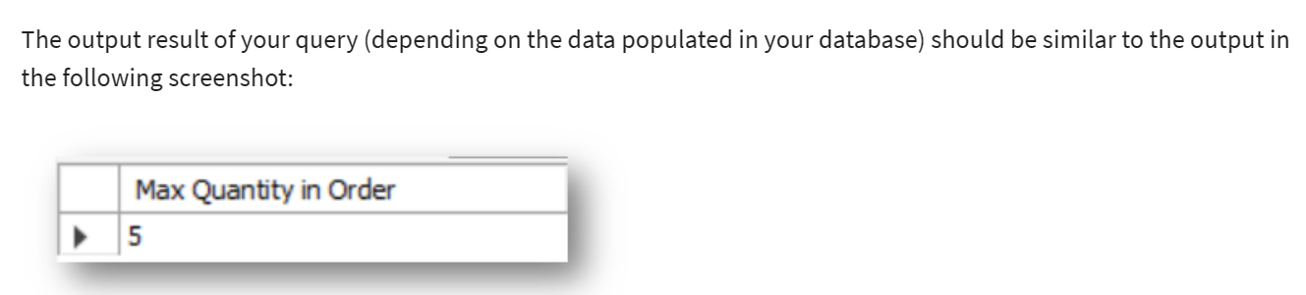

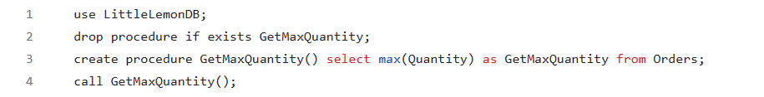

### Task 3.2

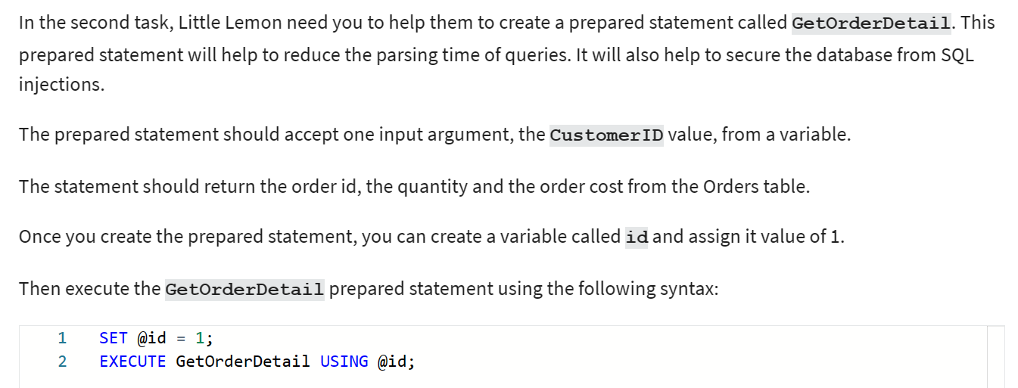

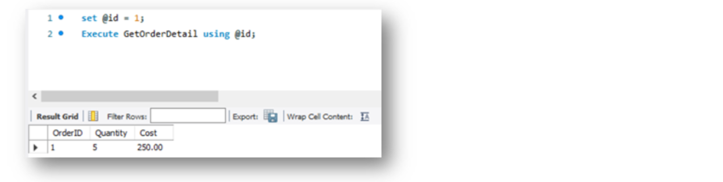

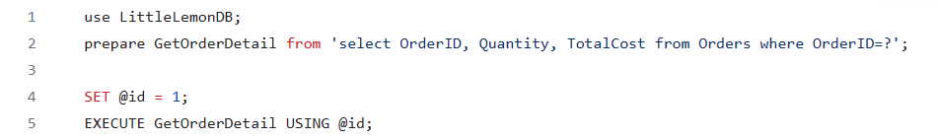

### Task 3.3

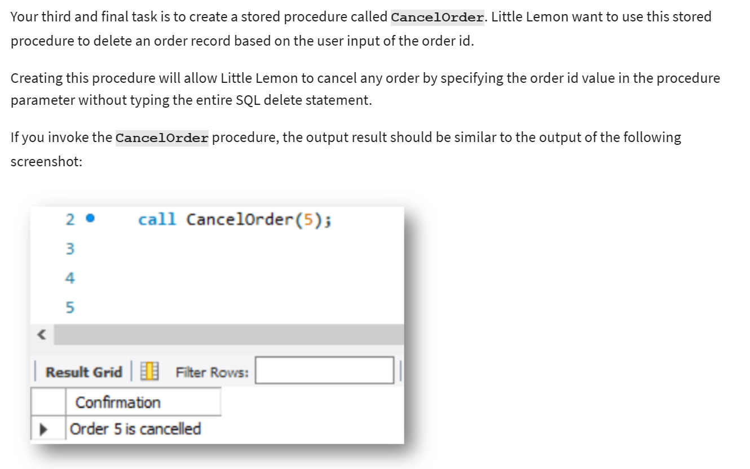

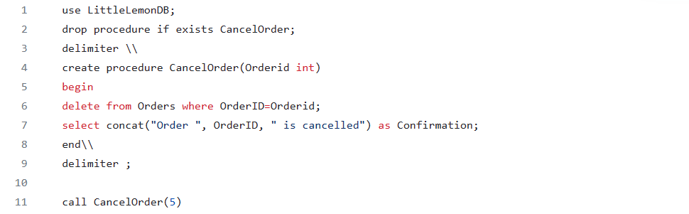

## Exercise 4: Create SQL queries to check available bookings based on user input

**Scenario**

Little Lemon’s data model must include a Bookings table so that they can store data for table bookings. They also need a stored procedure that checks available bookings based on user input, and a MySQL transaction that can be used to cancel bookings. Use your knowledge of MySQL to help them out.

**Prerequisites**

You should have created the Little Lemon database in an earlier module. This database should contain a basic Bookings table linked to a Customers table as illustrated below. Your tables can differ slightly from those provided in the example once the required relationship exists between the two.

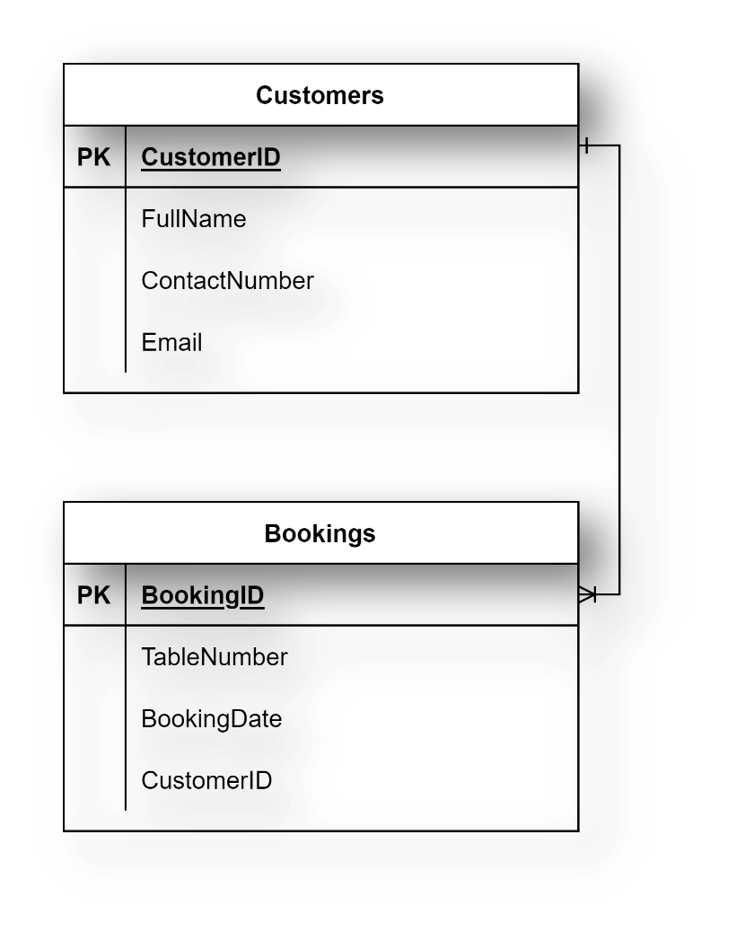

You also require access to MySQL Workbench SQL editor to write the required queries.

### Task 4.1

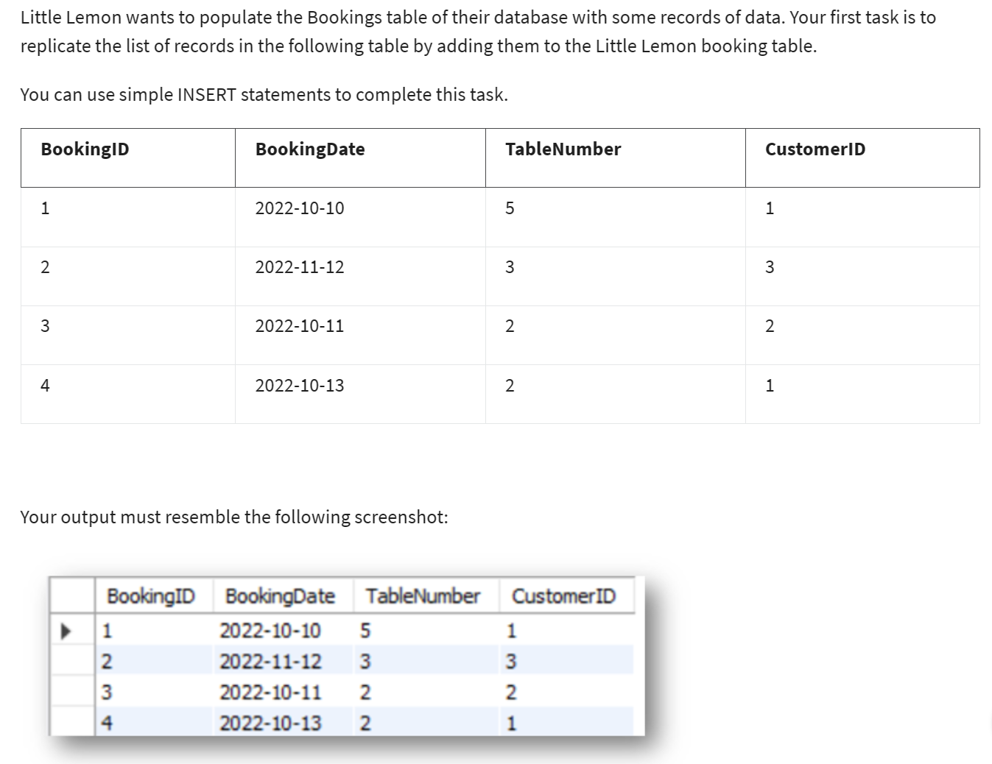

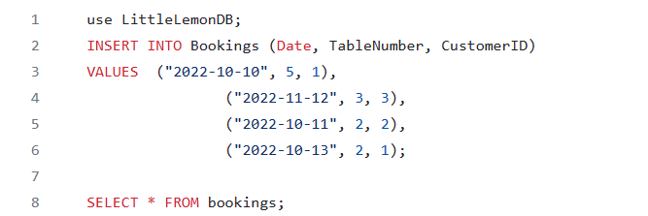

### Task 4.2

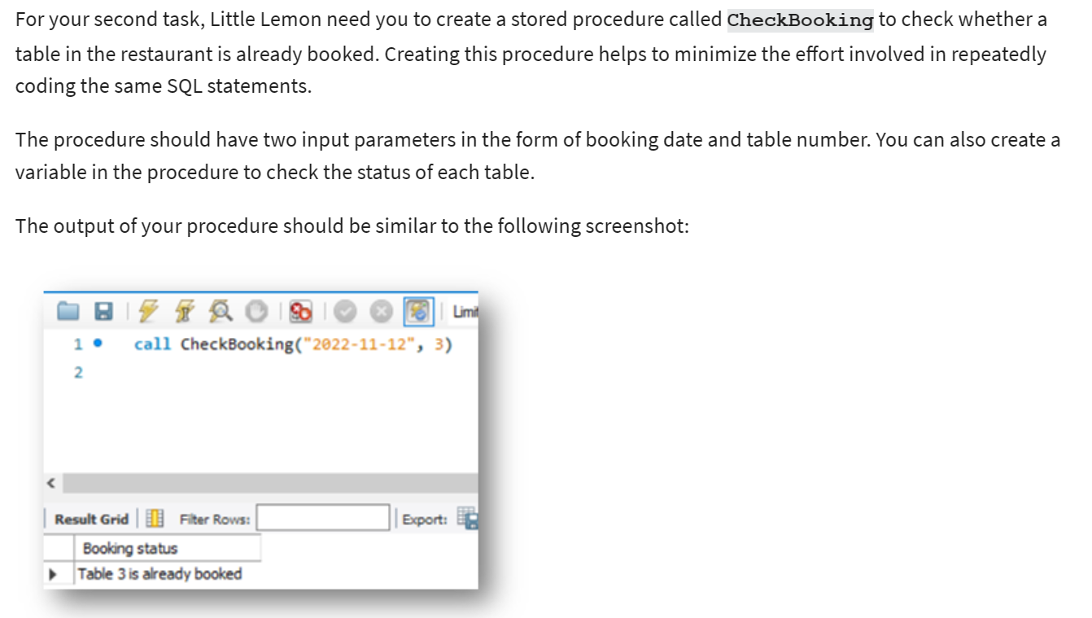

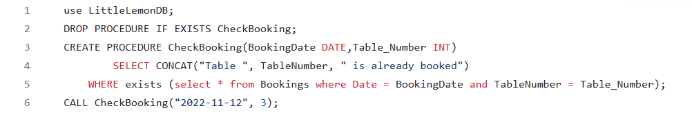

### Task 4.3

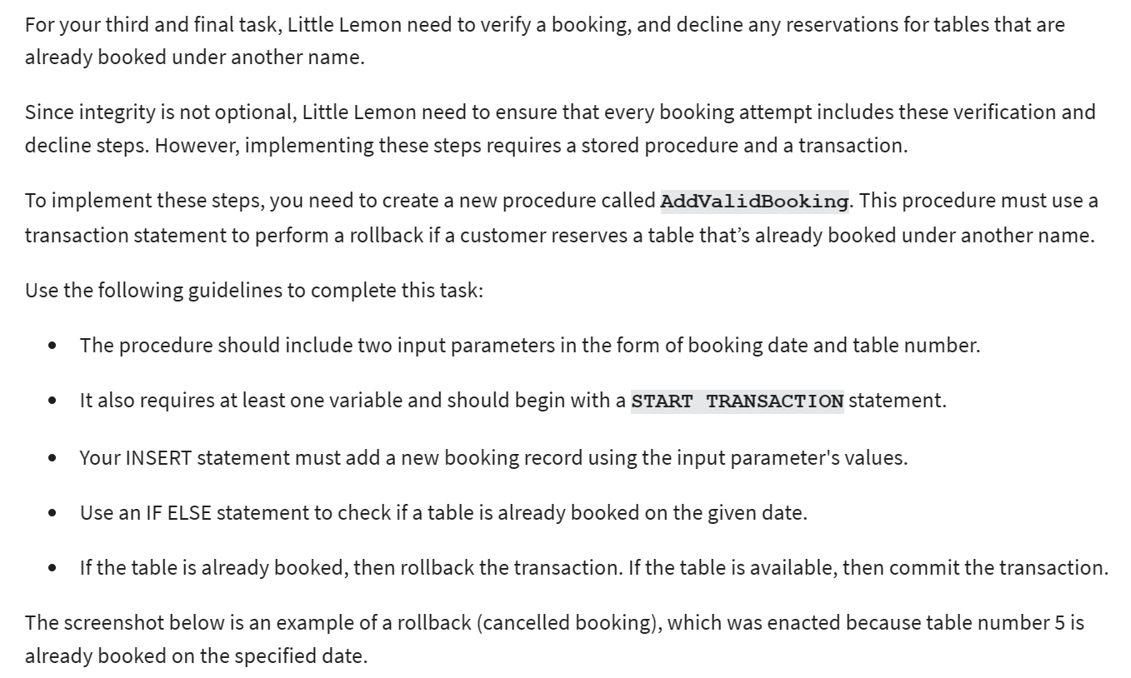

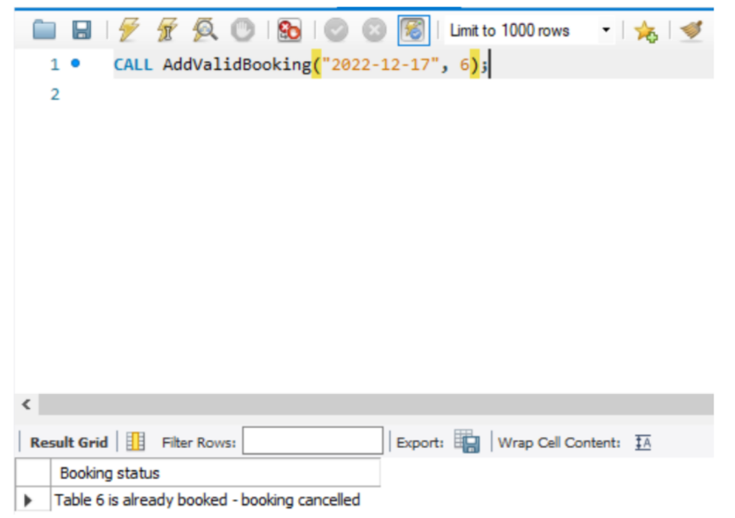

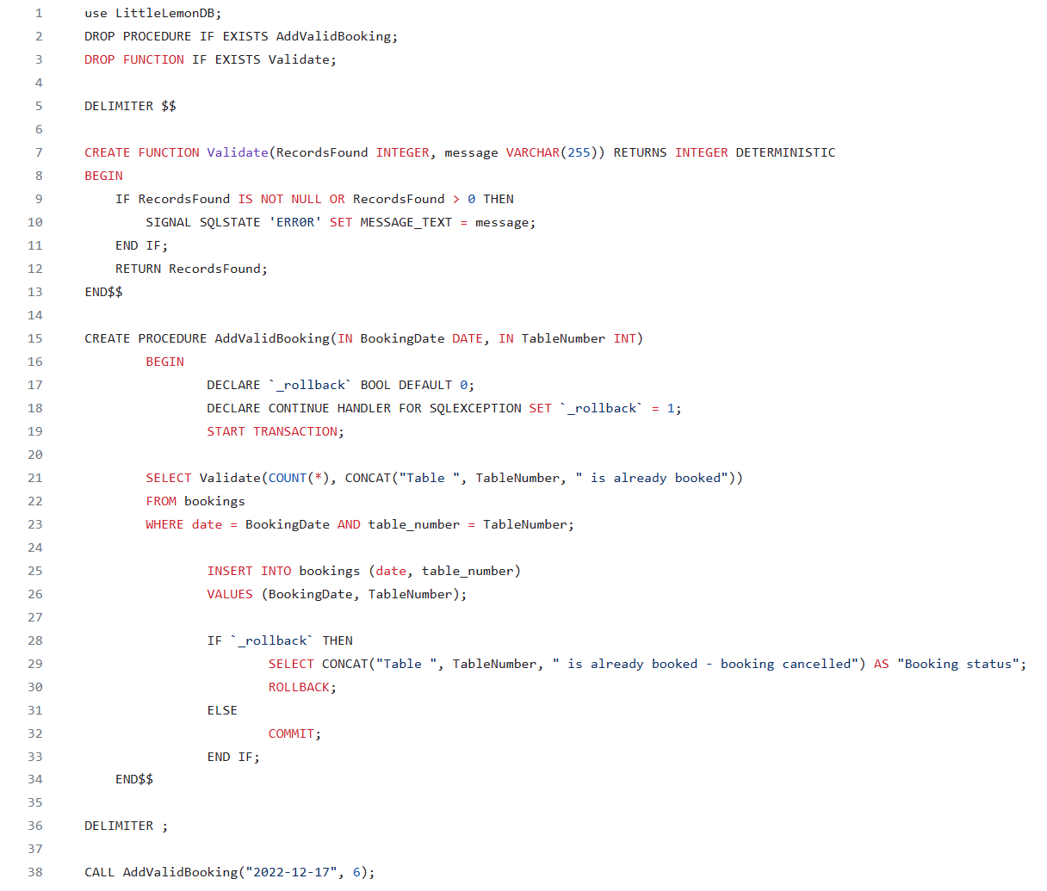

## Exercise 5: Create SQL queries to add and update bookings

**Scenario**

Little Lemon’s data model must include a Bookings table so that they can store data for table bookings. They also need a stored procedure that checks available bookings based on user input, and a MySQL transaction that can be used to cancel bookings. Use your knowledge of MySQL to help them out.

**Prerequisites**

You should have created the Little Lemon database in an earlier module. This database should contain a basic Bookings table linked to a Customers table as illustrated below. Your tables can differ slightly from those provided in the example once the required relationship exists between the two.



You also require access to MySQL Workbench SQL editor to write the required queries.

### Task 5.1

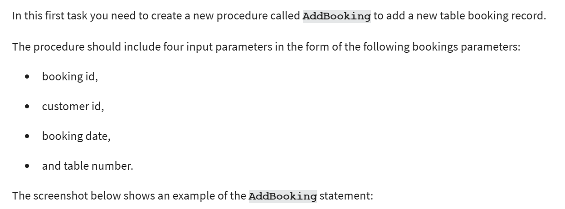

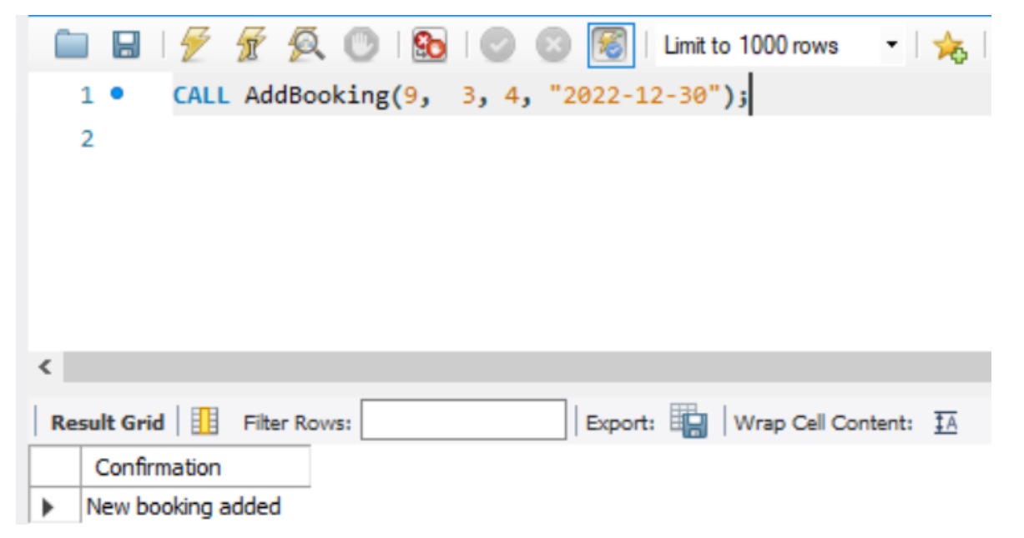

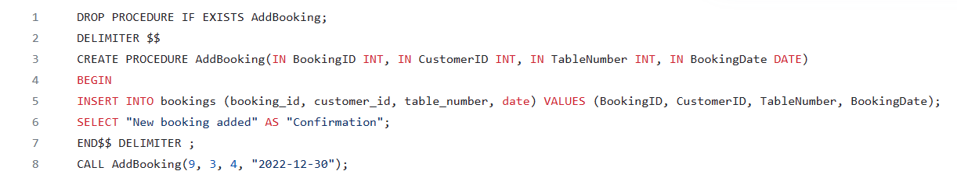

### Task 5.2

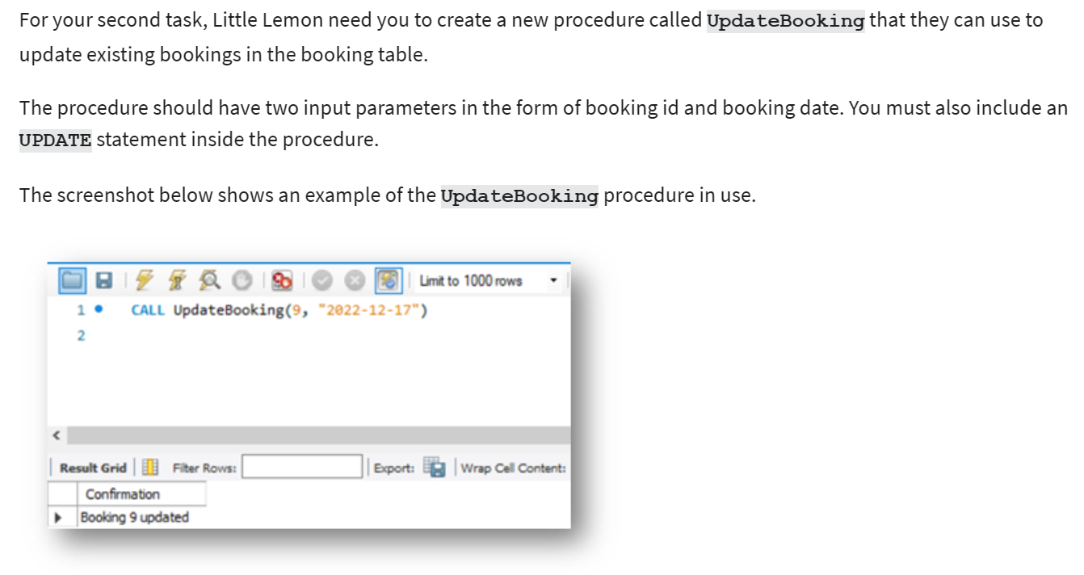

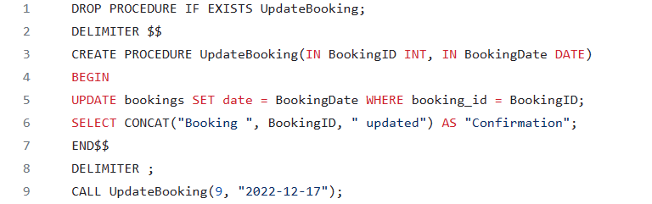

### Task 5.3

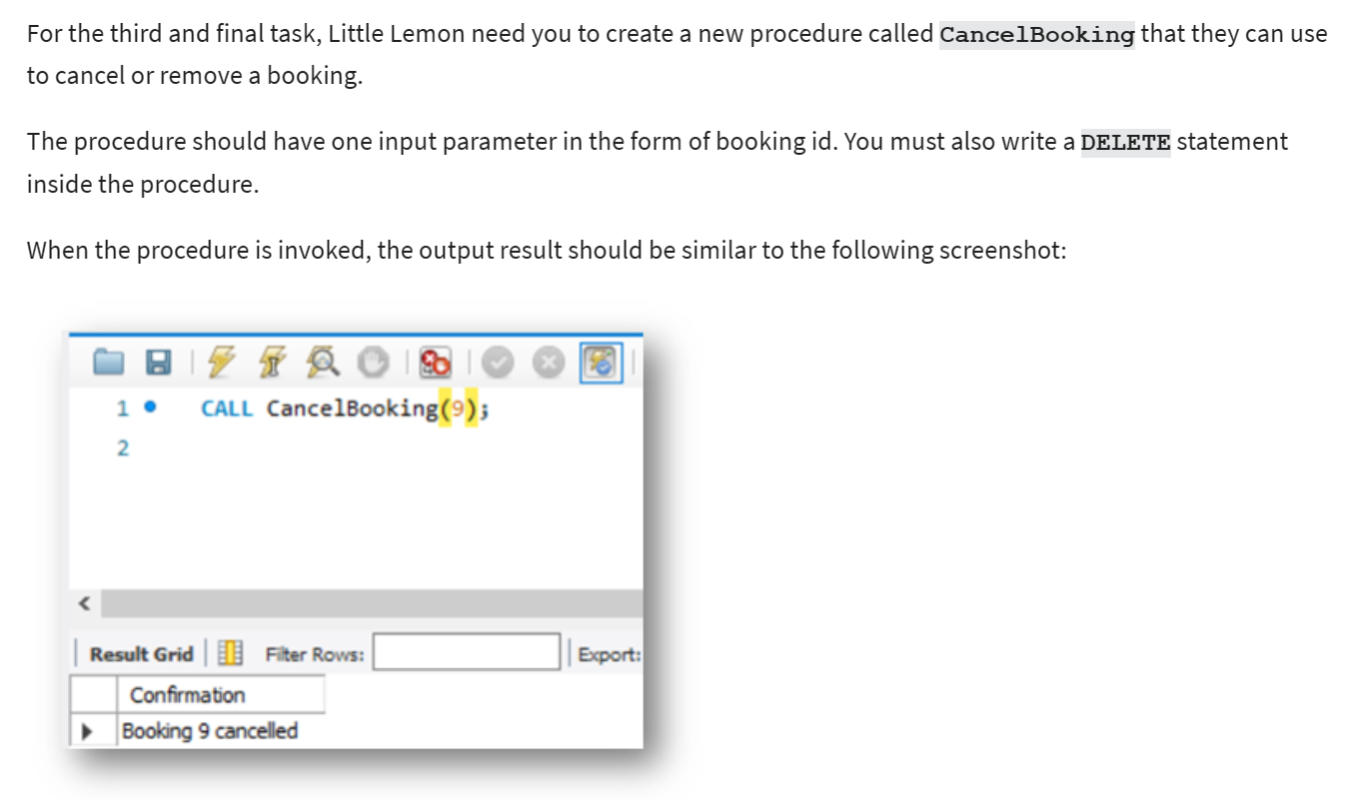

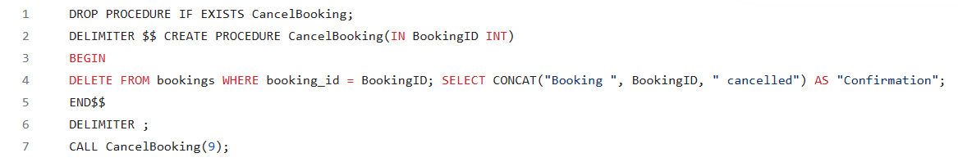

## Exercise 6: Create interactive dashboard for sales and profits

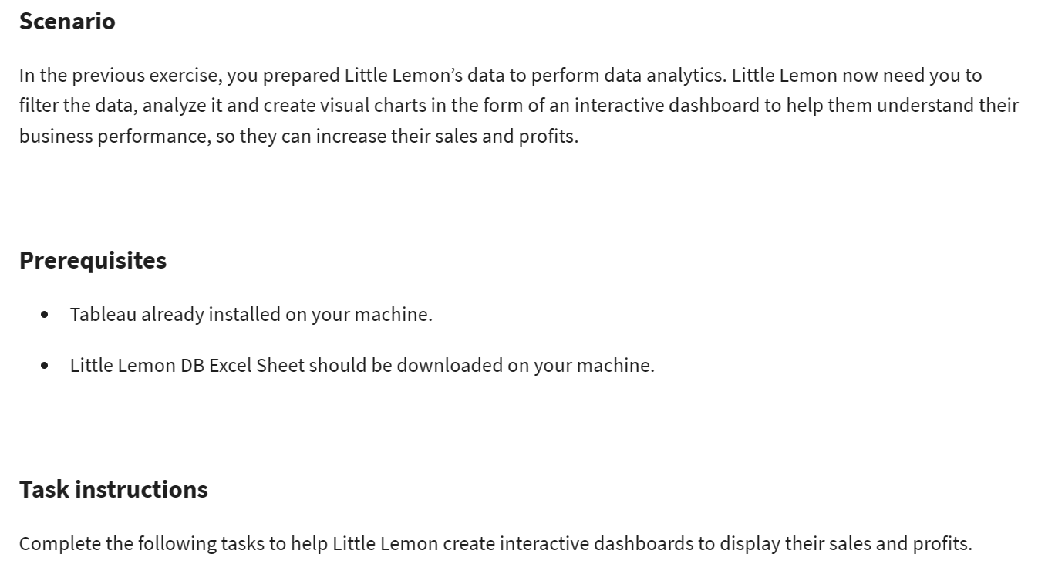

### Task 6.1

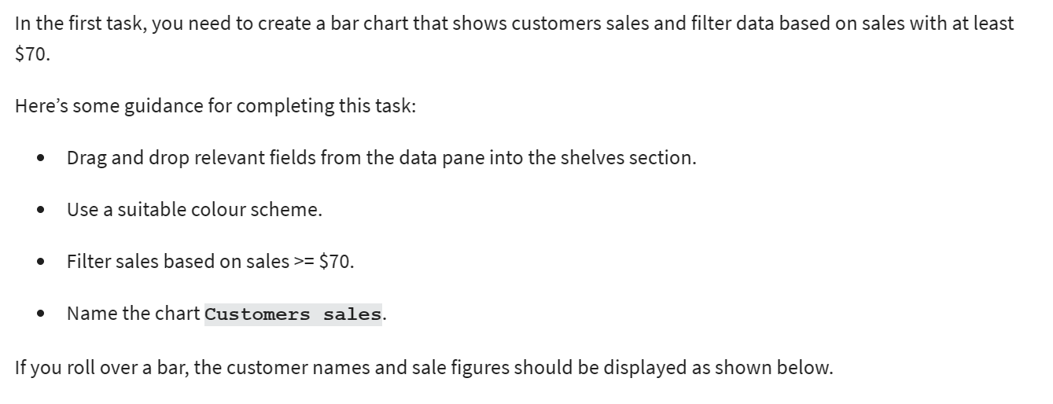

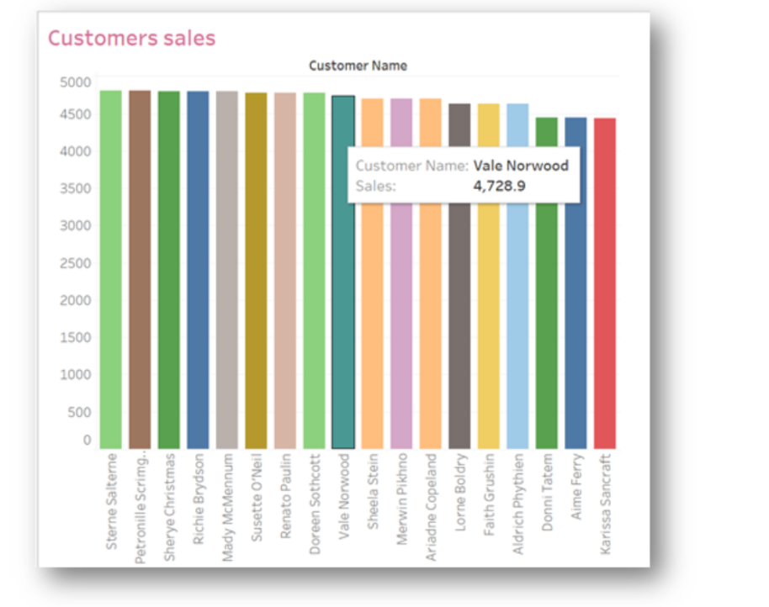

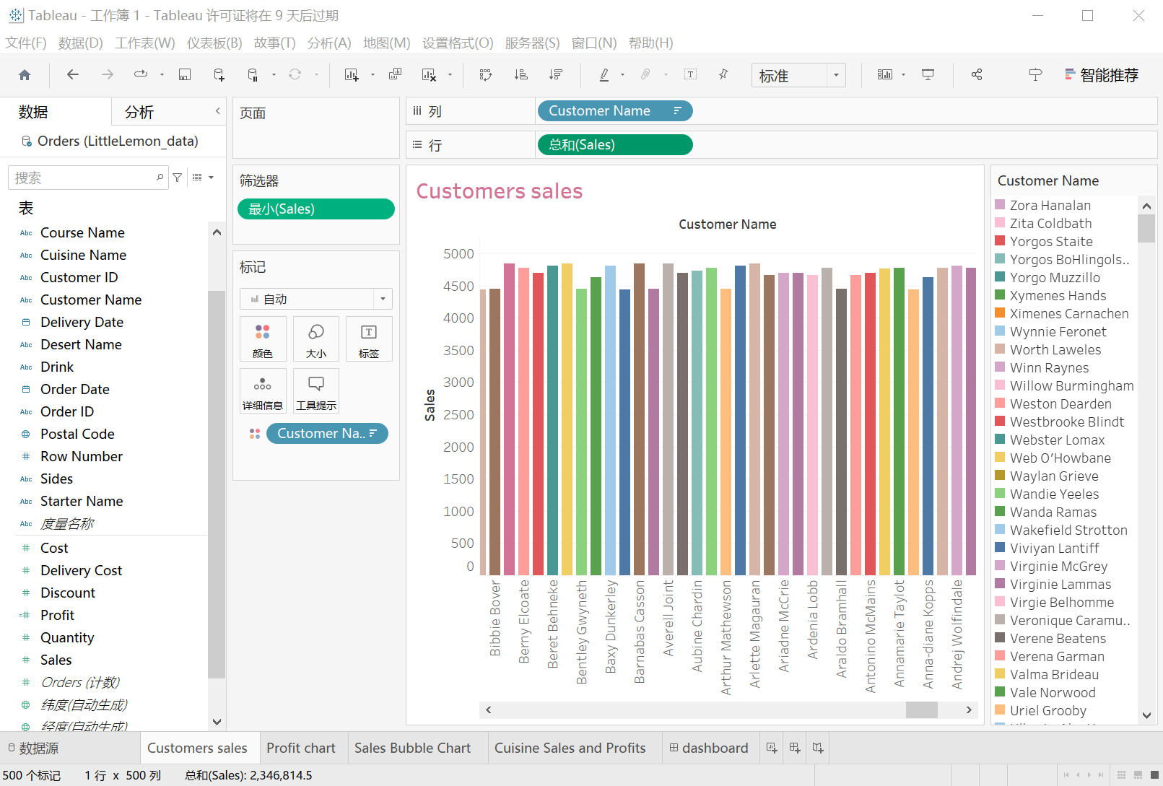

### Task 6.2

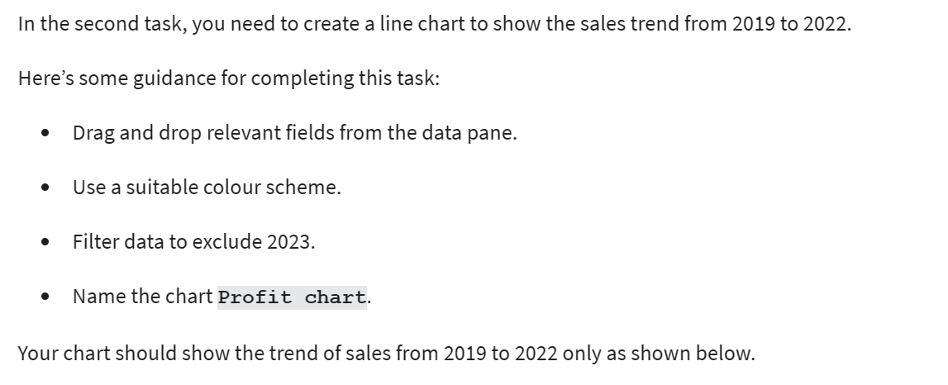

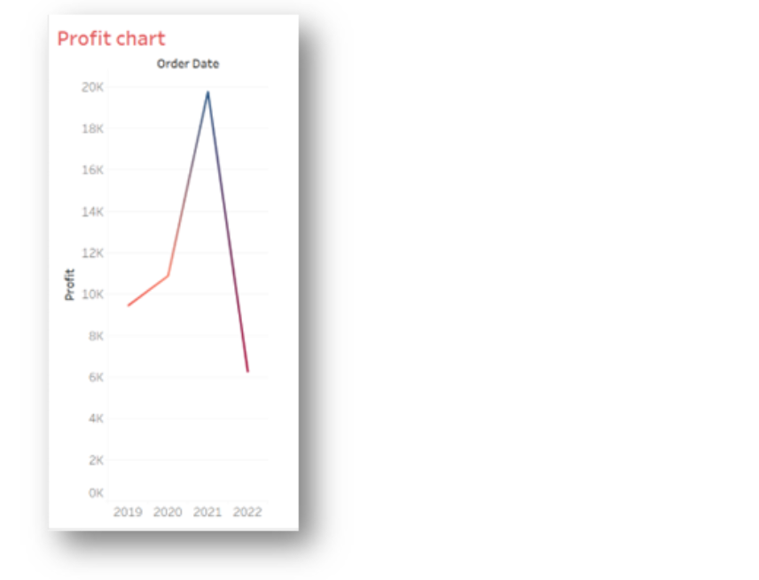

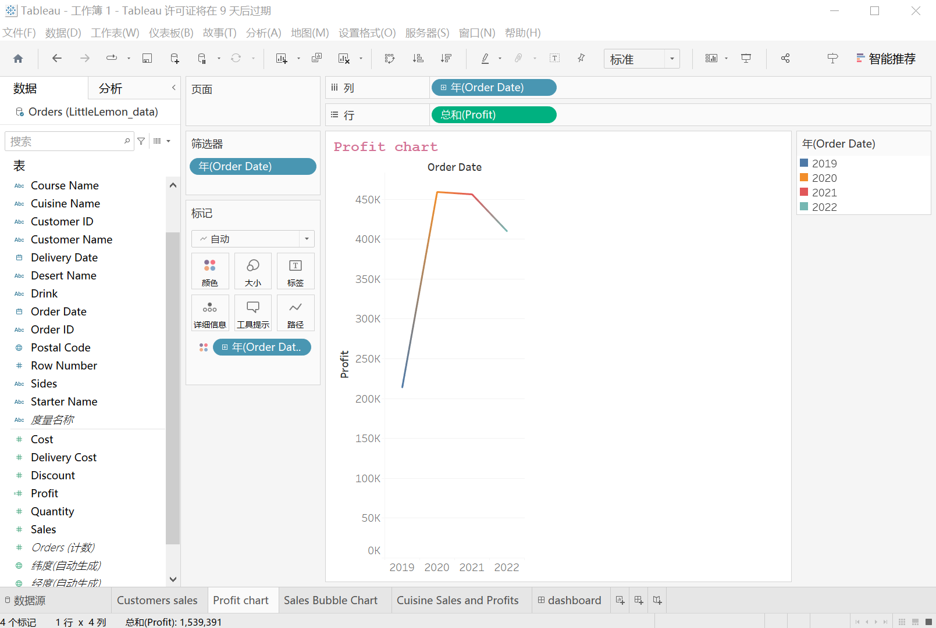

### Task 6.3

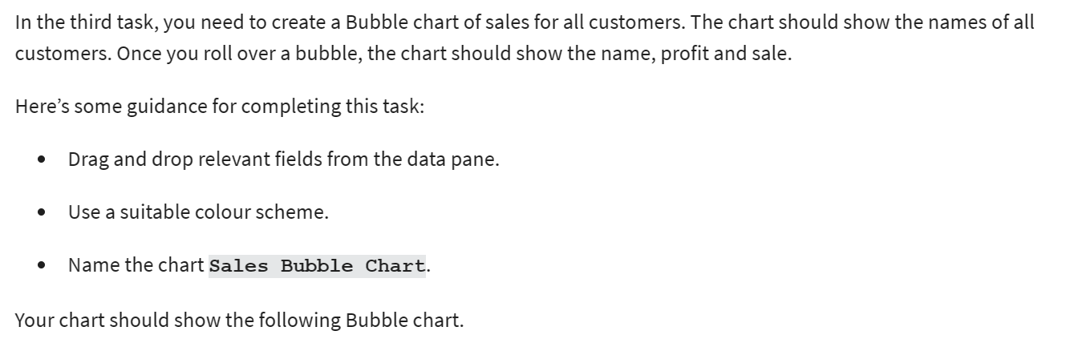

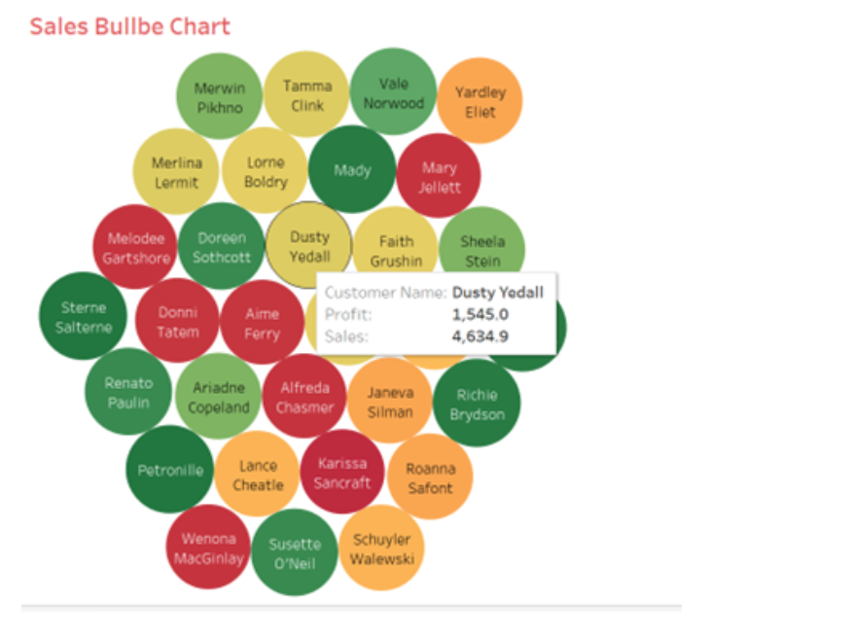

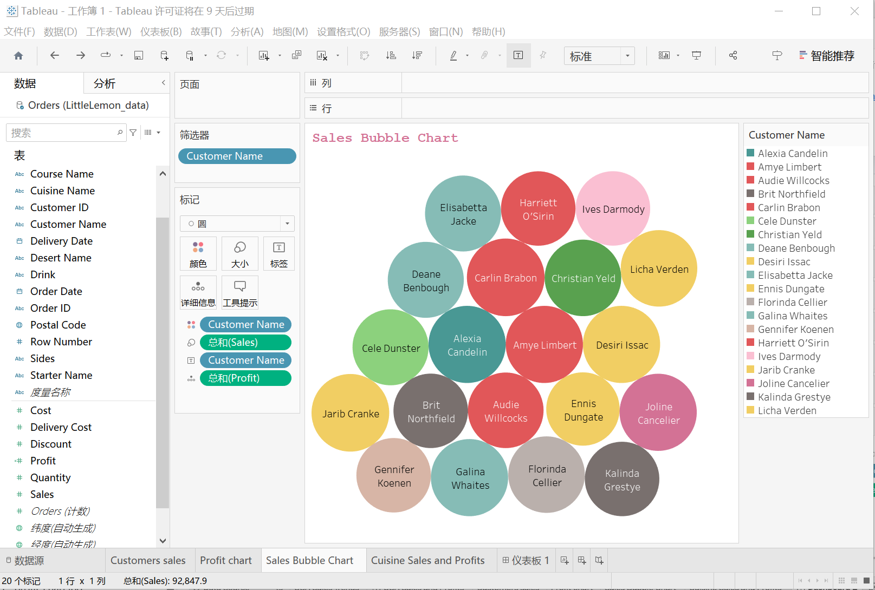

### Task 6.4

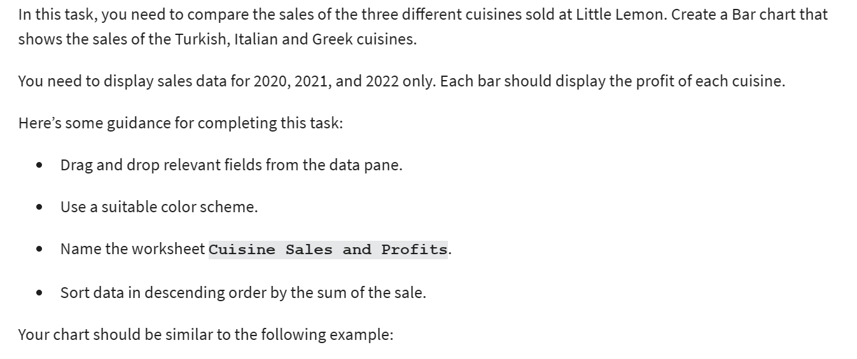

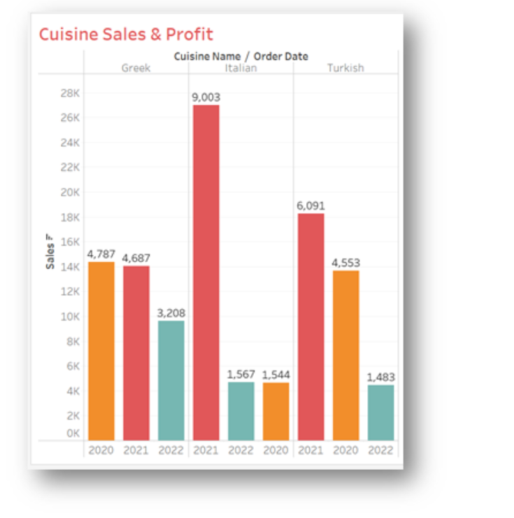

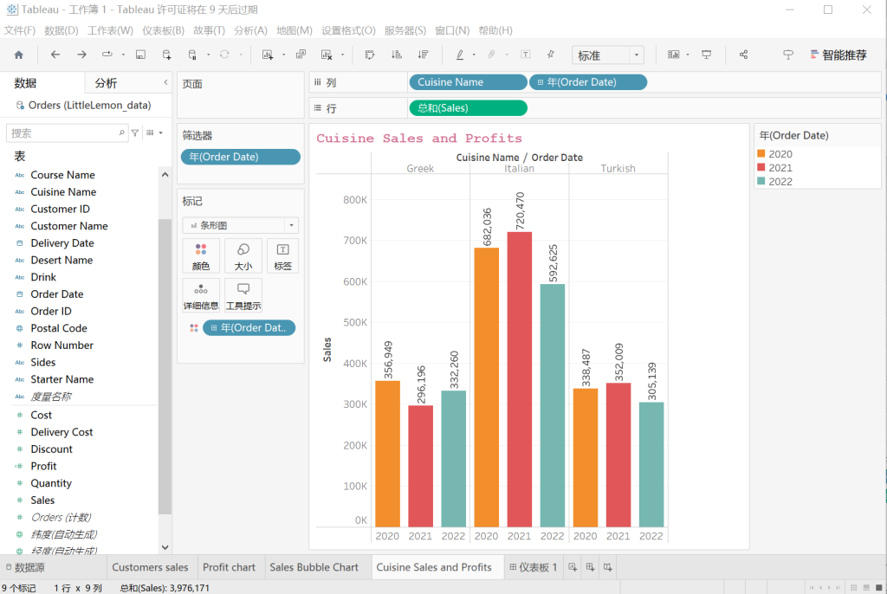

### Task 6.5

